CHAPTER 8

Developer Tools and DevOps: Part 2

Introduction
As modern cloud applications grow increasingly complex, seamless integration, automation, and scalability are critical for efficiency and reliability. AWS offers a comprehensive suite of developer tools and DevOps services, enabling organizations to build, manage, and deploy cloud-native applications at scale. This chapter explores advanced AWS services for application integration, container orchestration, robotics, and quantum computing, enabling optimized workflows and innovation-driven development.

Structure
This chapter brings us to Developer Tools' second and final part, diving deeper into AWS services for application integration, container management, robotics, and quantum technologies. We will cover the following topics:
- Application Integration
  - Application Integration
  - Amazon AppFlow
  - Amazon EventBridge
  - Amazon Managed Workflows for Apache Airflow (MWAA)
  - Amazon MQ
  - Amazon Simple Notification Service (SNS)
  - Amazon Simple Queue Service (SQS)
  - Managed message queues
  - Application Integration
  - AWS Step Functions
- Containers
  - Amazon Elastic Container Registry (ECR)
  - Amazon Elastic Container Service (ECS)
  - Amazon Elastic Kubernetes Service (EKS)
  - AWS App2Container
  - AWS Copilot
  - AWS Fargate
  - Red Hat OpenShift Service on AWS
  - Managed OpenShift in the cloud
- Robotics
  - AWS RoboMaker
- Quantum Technologies
- Amazon Braket

Learning Objectives
By the end of this chapter, you will understand the role of AWS application integration services in modern cloud architecture and explore container management solutions such as Amazon EKS and AWS App2Container. You will also analyze how AWS supports robotics development through AWS RoboMaker and examine AWS’s quantum computing capabilities, with a focus on Amazon Braket for experimenting with quantum algorithms. Finally, this chapter will help you identify the best practices for using AWS DevOps tools to automate, optimize, and scale cloud applications efficiently.

AWS application integration services
AWS offers a comprehensive suite of services for seamless application integration, enabling organizations to build scalable, efficient, and connected applications. Integrating different software applications and systems ensures efficient data flow, real-time communication, and interoperability, streamlining business processes and enhancing overall productivity. [1]. Key services include:
- Amazon Simple Queue Service: Simple Queue Service (SQS) is a fully managed message queuing service that helps decouple application components, promoting scalability and fault tolerance by ensuring reliable message delivery.
- Amazon Simple Notification Service: Simple Notification Service (SNS) is a flexible messaging service that facilitates communication between distributed components, enabling seamless delivery across microservices.
- Amazon AppFlow: This service enables secure integration between AWS services and SaaS applications, allowing for automated data flows to and from various platforms.
- Amazon EventBridge: EventBridge simplifies event-driven integration by connecting application data with various AWS services and enabling real-time event processing.
These services provide a robust infrastructure to connect diverse applications, systems, and data sources, promoting business agility, enhanced decision-making, and overall system reliability.
To better illustrate how these services integrate applications and data sources seamlessly, Figure 8.1 below highlights AWS Application Integration services and their key functionalities:
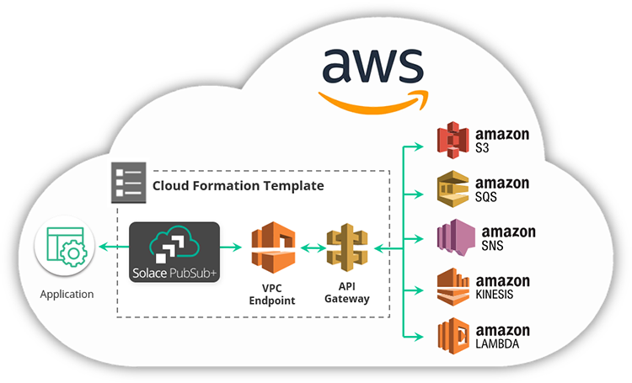
Figure 8.1AWS Application Integration Services (AWS Training Blog)

Application integration allows different systems and software to work together, ensuring efficient data flow and real-time communication. This process ensures smooth data exchange and real-time communication, enabling organizations to create more agile and responsive business operations. [2]. Modern cloud computing ensures that systems communicate and share data effectively. Key integration strategies include using an Enterprise Service Bus (ESB) as middleware to connect applications, API-based integration for seamless data exchange, and an event-driven architecture to manage real-time data responses. The significance of application integration lies in its ability to synchronize data across various systems, minimize errors, and reduce manual processes. [3]. Furthermore, it improves decision-making by offering a holistic data view, empowering organizations to quickly act on the most relevant insights. [4].
Asynchronous communication via SQS is crucial in microservices architectures, where services interact through events and messages. The following figure illustrates a typical AWS microservices application, highlighting the integration services' role in supporting these architectures.
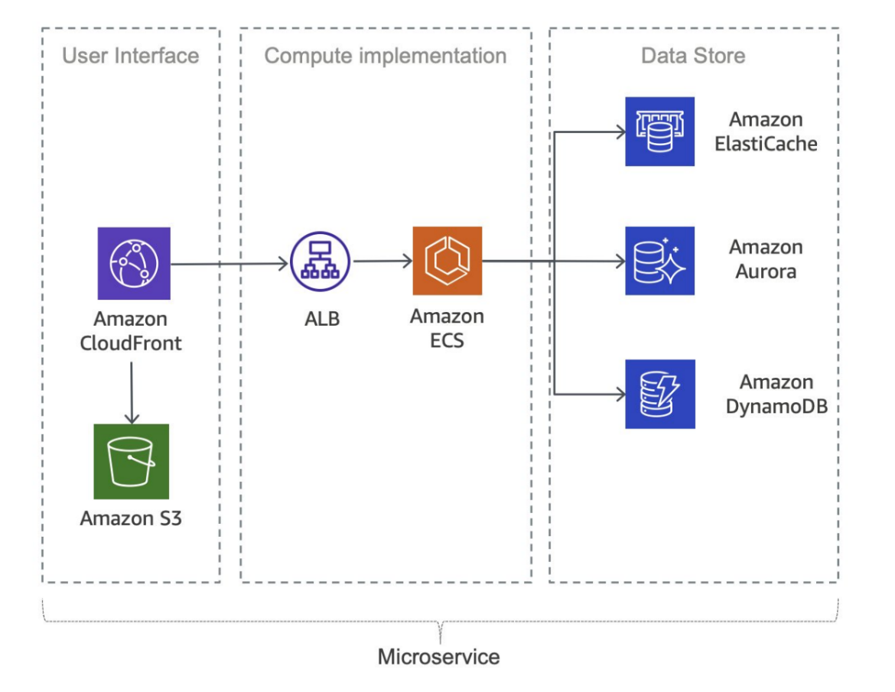
Figure 8.2: Typical microservices application on AWS (AWS Documentation)

Significance of application integration
Application integration is crucial in modern software ecosystems as it ensures data consistency across various platforms, enhances efficiency, and facilitates better decision-making. Through seamless communication between applications, integration cuts data silos and minimizes manual tasks, driving operational efficiency. [3]. Moreover, when systems work cohesively, businesses can make informed, data-driven decisions, promoting agility and innovation. [4].
With the growing need for dynamic, real-time capabilities, integrating applications ensures that organizations can react promptly to changes, whether scaling operations, responding to market shifts, or addressing customer demands. Organizations can achieve a unified view of their processes through integrated systems, ensuring they stay competitive in fast-moving industries. [1].

Strategies for application integration
Different strategies are essential for implementing effective application integration in cloud-native environments. An Enterprise Service Bus (ESB) is a common approach. This middleware enables communication between disparate systems and services through a central hub. [5]. This approach simplifies the management of communications between applications, ensuring that they interact in a standardized manner.
Another strategy involves API-based integration, where applications communicate via APIs. This approach offers flexibility, scalability, and easy data exchange across services, allowing applications to work independently while sharing necessary functionality. [1]. The third strategy is adopting event-driven architectures, where systems communicate by triggering events based on specific actions or changes in the environment, thus enabling real-time responses. [6].

Best practices for effective application integration
Follow best practices for seamless integration. Standardizing data formats is efficient for compatibility between applications and guarantees the smooth flow of information. [3]. Robust security measures, including encryption and authentication, are essential for safeguarding sensitive data during integration processes. [4]. Additionally, adopting event-driven design principles enhances flexibility and scalability by allowing applications to interact through events rather than direct calls, which decouples components and simplifies system architecture. [1].
Another best practice is decoupling components, where systems like Amazon SQS (Simple Queue Service) manage asynchronous communication between applications. This decoupling allows services to scale independently and promotes system reliability, making applications more adaptable to changes and failures. [6].

Amazon AppFlow
Amazon AppFlow is a fully managed integration service provided by AWS. It enables secure and efficient data transfer between AWS services and various SaaS (Software as a Service) applications. As businesses increasingly rely on cloud-based applications, Amazon AppFlow helps ensure seamless data flows, supporting operational efficiency and enhancing platform decision-making capabilities.

Key features
Amazon AppFlow offers critical features that enhance its utility for organizations seeking to improve their data integration strategies. [7]. These include:
- Bidirectional data flow: AppFlow supports bidirectional data transfer, enabling seamless data movement in both directions between AWS services and external SaaS applications. This flexibility allows organizations to integrate various systems efficiently while maintaining consistent data flows.
- Pre-built connectors: The service offers pre-built connectors for popular SaaS applications, including Salesforce, ServiceNow, and others, streamlining the integration process. These connectors simplify the connection between AWS and SaaS platforms, reducing the need for manual configurations.
- Data mapping and transformation: AppFlow enables automatic data mapping and transformation, ensuring compatibility between different data formats across source and destination systems. This feature allows seamless data transfer and processing with no format mismatches.
Use cases
Everyday use cases highlight the practical benefits of Amazon AppFlow:
- Sales and marketing automation: Businesses can automate the data flow between Customer Relationship Management (CRM) systems, such as Salesforce, and marketing platforms. This automation streamlines sales and marketing processes, helping organizations to keep up-to-date customer data and improve marketing campaign effectiveness [8].
- Data warehousing: AppFlow facilitates data transfer from SaaS applications into AWS-based data warehouses, enabling powerful analytics and reporting capabilities. By moving data to centralized storage solutions, organizations can leverage AWS’s analytical services to gain insights and make data-driven decisions [7].

Considerations for implementation
When implementing Amazon AppFlow, organizations must consider key factors to ensure seamless data transfers and integration. These considerations include:
- Security and compliance: Ensuring the security and compliance of data transferred through Amazon AppFlow is paramount. Organizations should show proper security protocols and ensure that data transfers meet regulatory requirements, especially when dealing with sensitive or personal data [7].
- Data mapping accuracy: To ensure the integrity of data flows, organizations must verify and assess their data mapping configurations. Any inaccuracies in mapping could lead to inconsistencies or errors in the transferred data, compromising the integration's effectiveness.

Challenges
While Amazon AppFlow offers robust integration capabilities, specific challenges may arise during implementation:
- Data transfer speed: The data transfer rate between SaaS applications and AWS services is determined by the amount of data and the functionality of the SaaS application. Organizations need to account for potential bottlenecks and consider transfer speed when designing data integration processes [9]. Planning for these challenges will ensure that integration continues smoothly and data flows as efficiently as possible.

Amazon EventBridge
Amazon EventBridge is an AWS serverless event bus service that simplifies the development of event-driven applications. This service enhances the scalability and flexibility of cloud architectures by enabling seamless communication between different services through events.

Key features
Amazon EventBridge provides features. [10]:
- Event routing: The service allows the creation of event rules that route events from sources to one or more targets, promoting decoupled service communication.
- Schema registry: EventBridge includes a schema registry, ensuring consistency and compatibility in event formats across applications.
- Managed integration: The service's event-driven architecture.
Use cases
Amazon EventBridge serves various use cases:
- Microservices communication: EventBridge facilitates communication between microservices by enabling them to publish and subscribe to events, which encourages a loosely coupled architecture [11].
- Real-time data processing: Organizations can use EventBridge for real-time data processing, responding to events generated by different services or applications [10].

Best practices
To maximize the effectiveness of EventBridge, follow these best practices. [10]:
Event schema design: Design event schemas for clarity, extensibility, and long-term maintainability.
- Rule filtering strategies: Develop efficient rule filtering strategies to manage event flow and enhance event-driven workflows.

Challenges
While EventBridge offers a robust framework for event-driven applications, there are challenges:
- Event consistency: Ensuring consistency in event formats and schemas across diverse services and teams require comprehensive communication and documentation [11].

Amazon managed workflows for Apache Airflow.
Amazon Managed Workflows for Apache Airflow (MWAA) is a fully managed service that simplifies the orchestration of complex workflows, cutting the operational overhead of managing Apache Airflow environments. This service enhances the scalability and reliability of workflows, making it ideal for orchestrating data-intensive tasks across various cloud resources. Figure 8.3 provides an overview of Amazon MWAA's architecture.
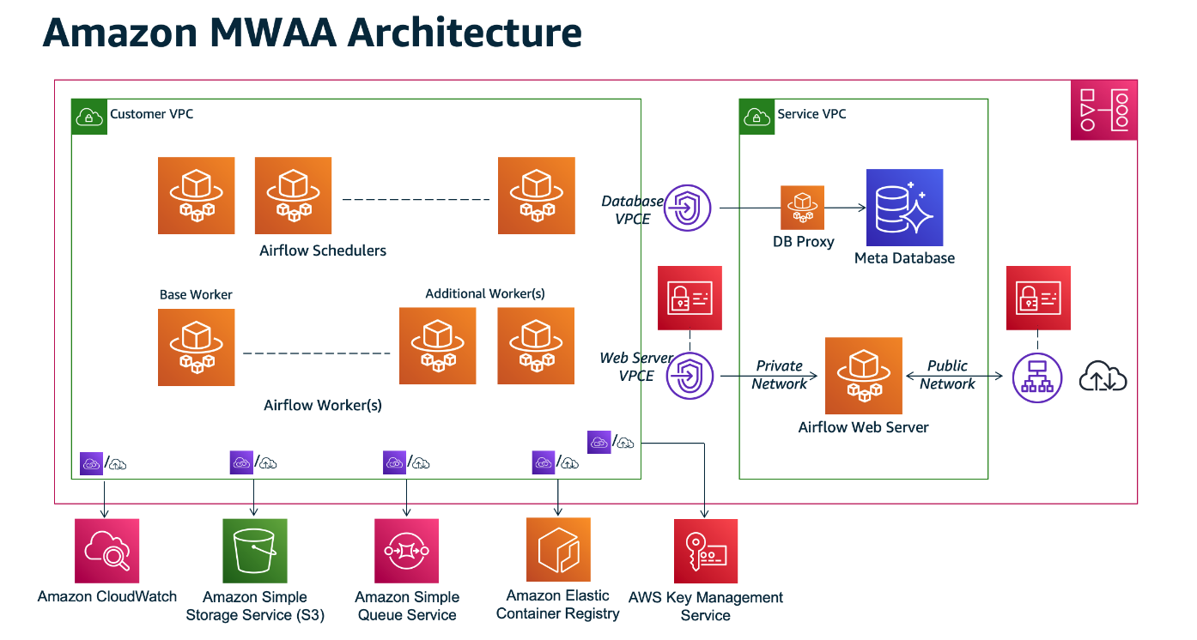
Figure 8.3Amazon Managed Workflows for Apache Airflow Architecture (AWS Documentation)

Key features
Amazon MWAA offers different key features that make it a powerful tool for workflow automation. [12]:
- Managed Apache Airflow environment: The service provides a fully managed environment, reducing the burden of infrastructure management.
- Scalability and reliability: MWAA automatically scales resources based on workload requirements, ensuring high performance and reliability.
- Integration with AWS services: Seamless integration with various AWS services allows workflows to interact effectively with cloud resources.
Use cases
MWAA is particularly useful for the following use cases:
- Data processing pipelines: They help automate data workflows across diverse data sources and destinations [13].
- ETL workflows: MWAA efficiently orchestrates ETL tasks, streamlining data processing for analytics and reporting [12].

Best practices
To maximize the benefits of Amazon MWAA, follow these best practices. [13]:
- Environment configuration: Configure the Airflow environment to improve performance and security.
- Monitoring and logging: Implement robust monitoring and logging systems to track workflow performance and promptly identify issues.

Considerations
MWAA's powerful features require careful consideration for effective implementation:
- Cost management: As workflows scale, watch, and manage associated costs, particularly when integrating data-intensive services [12].
- Security configuration: Ensure robust security practices, including proper IAM roles, data encryption, and AWS security best practices.
- Performance optimization: Tune task concurrency, use spot instances, and select the correct instance types to enhance performance and reduce costs.
- Dependency management: Manage dependencies effectively by utilizing MWAA’s support for Python packages, ensuring they are up-to-date and compatible.
- Compliance and governance: Ensure the utilization of tools like AWS CloudTrail for auditing and logging and verify that workflows adhere to relevant standards.
- Backup and recovery: Implement reliable backup strategies, using services like Amazon S3 for workflow definitions, and regularly evaluate recovery procedures.
- CI/CD integration: Incorporate MWAA workflows into CI/CD pipelines to ensure consistency and reliability across environments.
- Monitoring, alerts, and notifications: Set up CloudWatch metrics, alarms, and notifications to watch workflow execution and system performance.
- Data Privacy: Ensure data handling practices comply with privacy regulations, such as GDPR and CCPA, particularly when managing sensitive data.
- Training and documentation: Provide comprehensive training and operational documentation to ensure the effective use and maintenance of MWAA.
- Vendor lock-in and portability: Consider the implications of vendor lock-in and utilize infrastructure-as-code tools, such as AWS CloudFormation, to mitigate portability concerns.

Amazon MQ
Amazon MQ is a fully managed message broker service that simplifies the deployment and maintenance of popular messaging systems. This service supports multiple messaging protocols, including MQTT, AMQP, and STOMP, ensuring high compatibility with various applications and systems. By offering a managed infrastructure, Amazon MQ reduces the operational complexity typically associated with running messaging systems, allowing developers to focus on application logic.

Key features
The key features of Amazon MQ include [14]:
- Industry-standard compatibility: Amazon MQ supports various messaging protocols, including MQTT, AMQP, and STOMP, ensuring seamless integration with different systems and applications.
- Managed broker: It provides a fully managed message broker, minimizing the operational overhead of keeping the infrastructure and scaling the messaging system.
Use cases
Amazon MQ excels in the following use cases:
- Decoupled microservices communication: It helps communication between microservices in a decoupled manner, enhancing scalability and flexibility in microservices architectures [15].
- Event-driven architecture: Amazon MQ supports building reliable event-driven architectures by enabling applications to respond to events and messages in a scalable, efficient way [14].

Best practices
Follow these best practices to enhance Amazon MQ usage:
- Secure configuration: Secure the service by using IAM roles, encryption, and access control mechanisms to protect sensitive data [14].
- Scalability planning: Choose the correct instance types and configure resources based on expected message throughput and processing needs to ensure the best performance [15].

Considerations
Consider these factors when using Amazon MQ:
- Message retention and cleanup: Set the right retention policies and cleanup processes to manage storage costs and keep system efficiency [14].

Amazon's simple notification service
SNS is a fully managed messaging service that enables the decoupling of microservices, distributed systems, and serverless applications. This section examines the features, use cases, and best practices related to Amazon SNS.

Key features
The following are the key features of Amazon SNS. [16]:
- Publish-subscribe model: Amazon SNS adheres to a publish-subscribe messaging paradigm, enabling message producers to send messages to multiple subscribers simultaneously.
- Wide range of message protocols: The service supports various message protocols, including HTTPS, email/SMTP, SMS, and application-specific protocols, ensuring flexibility in message delivery.
Use cases
The following are the use cases of Amazon SNS. [16]:
- Event-driven architecture: Amazon SNS is crucial in building event-driven architecture, facilitating communication and coordination between loosely coupled components.
- Mobile application notifications: The service enables the sending of push notifications to mobile devices, thereby enhancing user engagement with mobile applications.

Best practices
The following are Amazon SNS's best practices. [16]:
- Topic organization: Organize topics effectively to reflect the structure of your application, making it easier to manage and control message distribution [17].
- Message filtering: Implement message filtering to control which subscribers receive specific messages based on their preferences or attributes.

Considerations
One efficiency consideration is message retention. Details of which are as follows:
- Message retention: Understand the default message retention periods and adjust them based on your application's requirements to avoid message loss [17].

Integration with other AWS services
Amazon SNS integrates with other AWS services to enhance various application development and deployment aspects. Notable integrations include:
Amazon Simple Queue Service (SQS): Facilitates asynchronous communication by directing SNS messages to SQS queues [18].
- AWS Step Functions: Helps coordinate distributed applications using SNS to trigger state transitions in Step Functions [19].

Amazon's simple queue service
SQS is a fully managed message queuing service that helps with decoupling components in a distributed system. This section examines features, use cases, and best practices related to Amazon SQS. Figure 8.4 illustrates the basic architecture of Amazon Simple Queue Service:
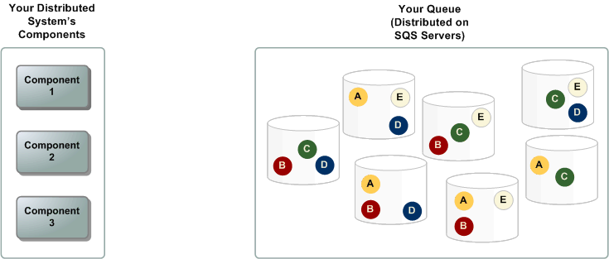
Figure 8.4: Amazon Simple Queuing Service Basic Architecture (SWS Documentation)

Key features
Amazon SQS provides different key features that enhance its utility in distributed systems. [20]:
- Scalability and elasticity: The service automatically scales to manage variable message volumes, ensuring reliable delivery even during workload fluctuations.
- Message retention: SQS enables users to define the retention period for messages, offering flexibility in managing how long messages remain in the queue.
Use cases
Amazon SQS is beneficial in various scenarios, including:
- Load leveling: SQS buffers and decouples message production and consumption rates to smooth traffic spikes [21].
- Task decoupling: SQS facilitates task decoupling in microservices architectures, enabling components to communicate asynchronously.

Best practices
To improve the use of Amazon SQS, follow these best practices:
- Visibility timeout: Adjust the visibility timeout to prevent duplication by hiding a message from other consumers while processing.
- Dead-letter queues: Implement dead-letter queues to capture undeliverable messages after a predefined number of attempts and analyze their failure [20].

Considerations
While Amazon SQS offers best-effort ordering, it is efficient to design systems that can manage potential out-of-order message delivery. [20].

Integration with other AWS services
SQS seamlessly integrates with various AWS services, enhancing its capabilities and applications in different scenarios. Notable integrations include:
- Amazon S3: Use SQS to trigger events when changes occur in an S3 bucket, supporting event-driven architecture. [20]
- AWS Lambda: Leverage SQS to trigger serverless functions in AWS Lambda, allowing for the seamless execution of compute workloads [18].

Managed message queues
Managed message queues are essential components of modern cloud architecture. They offer a scalable and reliable way to decouple system components. This section discusses the role of managed message queues and their importance in distributed systems.

Overview
Managed message queues, such as Amazon SQS, Azure Queue Storage, and Google Cloud Pub/Sub, provide a robust solution for enabling asynchronous communication in distributed systems. These queues help streamline message handling by ensuring scalability, reliability, and efficient decoupling between system components.

Advantages
Managed message queues offer advantages that enhance the performance and reliability of distributed systems:
- Scalability: These queues scale automatically to manage changing workloads, ensuring consistent performance as demand fluctuates [22].
- Reliability: By offloading the tasks of message storage and delivery to managed services, message processing reliability improves significantly.
- Decoupling: Managed message queues help the decoupling of producers and consumers, supporting asynchronous communication and reducing the interdependencies between components [23].
Use cases
Managed message queues are pivotal in different use cases:
- Microservices architectures: These queues enable microservices to communicate asynchronously, avoiding direct dependencies between services.
- Event-driven systems: In these systems, managed message queues facilitate the smooth transfer of events across components, enabling real-time processing.

Best practices
To maximize the efficiency of managed message queues, adhere to the following best practices:
- Message retention: Configure retention policies based on application needs, striking a balance between storage costs and messages' time-sensitive nature.
- Error handling: Implement robust error-managing mechanisms, including the use of dead-letter queues, to manage messages that do not process [20].

Integration with AWS services
Managed message queues integrate seamlessly with different AWS services, enhancing their capabilities in various scenarios. Key integrations include:
- AWS Lambda: Use managed message queues to trigger AWS Lambda functions, enabling serverless, event-driven architectures.
- Amazon EC2: Integrate with EC2 instances to allow communication between different components of a distributed application [20].

AWS step functions
AWS Step Functions is a fully managed service that enables developers to coordinate and automate the execution of serverless workflows using visual workflows. This section explores AWS Step Functions' capabilities, use cases, and benefits in application integration.

Overview
AWS Step Functions simplifies building scalable and resilient applications by allowing developers to design workflows using a visual interface. Step Functions depict workflows as state machines, where each state represents a step in the process.

Key features
The following are the key features of AWS Step Functions. [19]; [24]
- Visual workflow design: Step Functions provides a visual workflow designer, allowing developers to design, visualize, and change workflows easily.
- Coordination of microservices: It excels in coordinating microservices, enabling seamless communication and task execution across distributed applications.
- Error handling: Step Functions include built-in error management capabilities, allowing for the definition of error states and automatic retribution.
Figure 8.5 illustrates AWS Step Functions Microservice Orchestration, combining Lambda functions to build a web-based application.
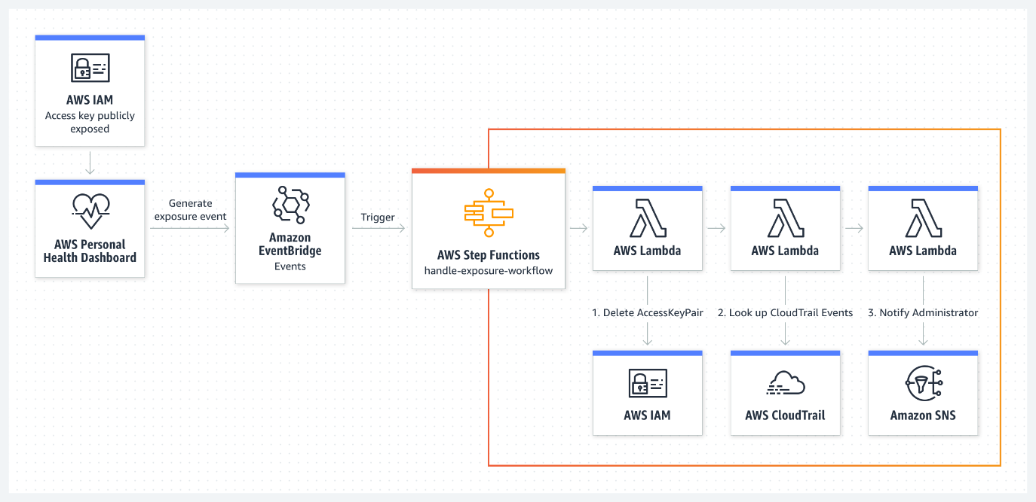
Figure 8.5AWS Step Functions Microservice Orchestration: (Amazon Web Services)
Use cases
The following are the use cases of AWS Step Functions [19]:
- Order processing workflows: Step Functions can orchestrate order processing workflows, coordinating tasks such as payment processing, inventory management, and shipping.
Data processing pipelines are ideal for constructing pipelines whose success or failure depends on the previous steps' success or failure.
- Media processing workflows: Step Functions can coordinate media processing tasks, such as video transcoding and image recognition, in a scalable and efficient manner.

Benefits
The following are the benefits of using AWS Step Functions. [19]:
- Simplified workflow management: The visual designer allows developers to easily manage complex workflows, thereby reducing the complexity of application integration.
- Scalability: Step Functions scale automatically based on the workload, ensuring that workflows execute reliably under varying conditions.
- Cost Efficiency: Step Functions' pay-as-you-go pricing model ensures cost efficiency, with charges based on the number of state transitions.
The benefits of using AWS Step Functions are as follows. [19]:
- Simplified workflow management: The visual designer makes it easy for developers to manage complex workflows, reducing the complexity of application integration.
- Scalability: Step Functions scale automatically based on the workload, ensuring that workflows execute reliably under varying conditions.
- Cost Efficiency: Step Functions' pay-as-you-go pricing model ensures cost efficiency, with charges based on the number of state transitions.

Integration with other AWS services
AWS Step Functions seamlessly integrates with various AWS services, including AWS Lambda, AWS Fargate, and Amazon SageMaker, enabling developers to utilize multiple functionalities within their workflows.

Amazon Elastic Container Registry
Amazon Elastic Container Registry (ECR) is a fully managed container registry service that enables developers to store, manage, and deploy Docker container images efficiently. This section explores Amazon ECR's features and role in the containerization ecosystem.
Amazon ECR simplifies containerization by offering a secure and scalable repository for Docker images, supporting the entire lifecycle of containerized applications.

Key features of Amazon ECR
The following are the key features of Amazon ECR. [25]; [26]:
Secure private repositories: ECR offers private repositories for secure container image storage, accessible only by authorized users and systems.
- Integration with AWS Services: It integrates seamlessly with AWS services, such as Amazon ECS and Kubernetes, facilitating containerized application deployment.
- Scalability: ECR scales with the development team's needs, efficiently managing the storage and retrieval of large container images.
Use cases
The following are the key features of Amazon ECR. [25]; [26]:
ECR provides private repositories for securely storing container images, accessible only by authorized users and systems.
- Integration with AWS Services: It integrates seamlessly with AWS services, such as Amazon ECS and Kubernetes, facilitating containerized application deployment.
- Scalability: ECR scales with the development team's needs, efficiently managing storage and retrieval of large numbers of container images
Figure 8.6 shows AWS Container options by layer:
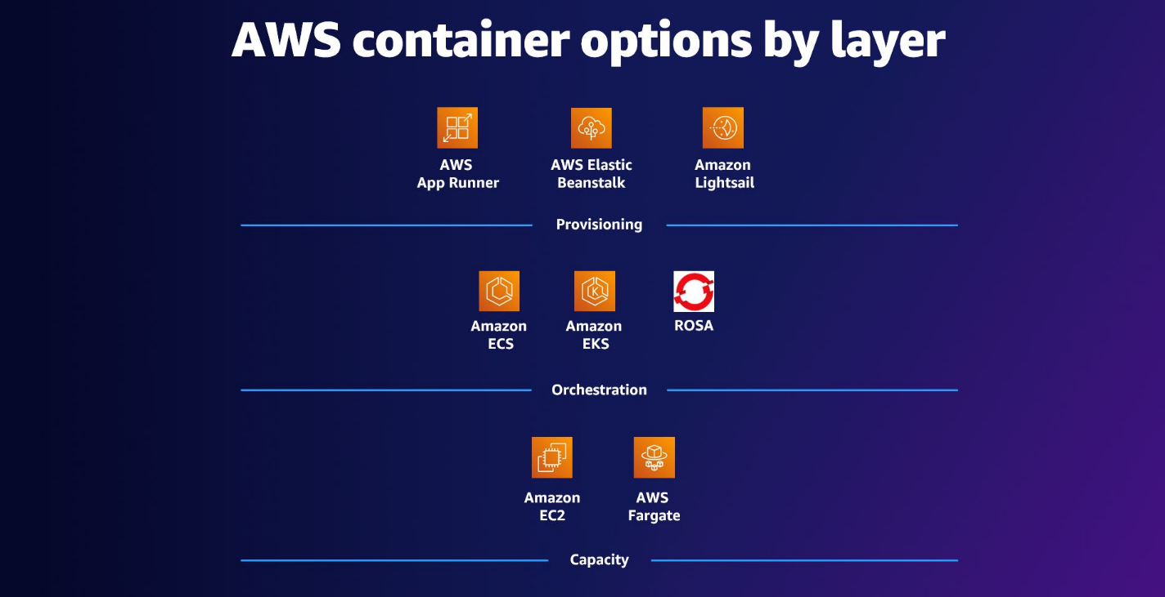
Figure 8.6AWS Containers (Amazon Web Services)

Benefits of using Amazon ECR
The benefits of using Amazon ECR are as follows: [25]:
- Ease of use: Integrating AWS services and Docker tools simplifies usage for novice and experienced container developers.
- Cost efficiency: ECR follows a pay-as-you-go pricing model, charging users based on storage and data transfer for container images.
- Comprehensive security: ECR provides fine-grained access control, integrating with AWS IAM to securely manage container image repositories.

Integration with DevOps workflow
Amazon ECR plays a pivotal role in DevOps workflows by integrating containerized applications into deployment pipelines. Its compatibility with CI/CD tools ensures a smooth transition from development to production.

Amazon Elastic Container Service
Amazon Elastic Container Service (ECS) is a fully managed service for container orchestration that simplifies the deployment and management of containerized applications. This section highlights ECS's features, architecture, and use cases, emphasizing its role in scaling these applications.
Amazon ECS enables users to run, stop, and manage Docker containers across clusters. It abstracts infrastructure complexities so developers can focus on scaling applications without managing the underlying resources.

Key features of Amazon ECS
The key features of Amazon ECS include [27]:
- Scalability: ECS automatically scales containers based on application load, ensuring efficient resource utilization.
- Integration, thereby improving load balancing.
- Task definitions: Developers define applications through task definitions, specifying Docker images, CPU, memory, and container links.

Amazon ECS architecture
Amazon ECS orchestrates Docker containers on EC2 instances or AWS Fargate, AWS's serverless compute engine for containers. The architecture revolves around clusters, tasks, and services. Clusters group EC2 instances or Fargate tasks, while tasks are discrete units of work defined by task definitions. ECS services manage the lifecycle, ensuring high availability and scalability [27].

Components of Amazon ECS
Amazon ECS architecture includes:
- Clusters: Groups of EC2 instances or Fargate tasks for container deployment.
- Tasks: Units of work defined by task definitions that specify Docker images, resource allocations, and dependencies.
- Services: Ensure high availability and scalability by managing task lifecycles and adjusting based on demand [27].

Scalability and integration
ECS scales containers dynamically in response to workload demands. Integrated with AWS Auto Scaling and ELB, ECS distributes traffic across containers, improving performance in microservices and batch-processing environments. [28].

Operational simplicity and benefits
ECS abstract infrastructure complexities, streamlining operations. It improves resource use, integrates with AWS IAM for secure container management, and supports CI/CD pipelines for automated testing and deployment, enabling rapid innovation. [27].
To better understand Amazon ECS's architecture and key components, Figure 8.7 below illustrates how the service orchestrates containerized applications across managed clusters, leveraging EC2 instances or AWS Fargate for scalable deployment.
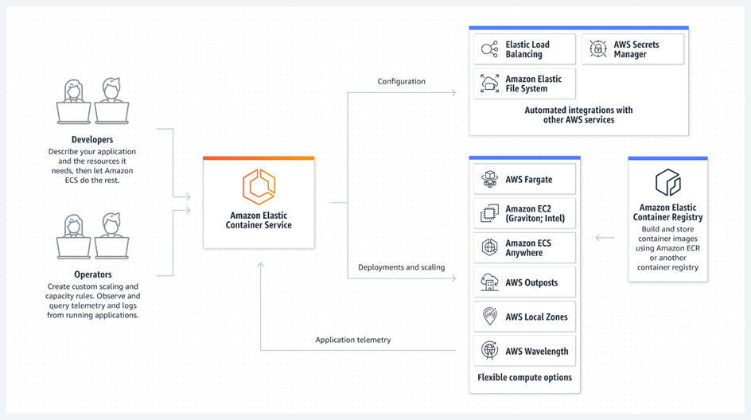
Figure 8.7: Amazon ECS (Amazon Web Services)
Amazon ECS architecture core components
ECS architecture includes:
- Clusters: Logical groupings of container instances or Fargate tasks.
- Tasks: Units of work based on task definitions, ensuring seamless execution across ECS clusters.
- Services: Manage the lifecycle and scaling of tasks to keep availability [27].
Use cases of Amazon ECS
ECS is ideal for:
- Microservices architecture: Efficient orchestration and scaling of microservices.
- Batch Processing: Scaling containerized applications dynamically in response to workload demands.
- CI/CD: ECS integrates with CI/CD pipelines for automated testing and deployment [28].

Benefits of using Amazon ECS
Key benefits of ECS include [27]:
- Cost efficiency: ECS improves resource utilization, charging users only for the compute resources they consume.
- Security: Integrated with AWS IAM for secure container management and access control.
- Operational simplicity: ECS abstracts infrastructure management, enabling developers to focus on building applications.
Integration with DevOps workflow
Amazon ECS integrates seamlessly with DevOps tools, enhancing the deployment and management of containerized applications in continuous integration and continuous deployment (CI/CD) pipelines.

Amazon elastic Kubernetes service
Amazon EKS is a fully managed Kubernetes service provided by AWS. It offers a simplified yet powerful platform for deploying, managing, and scaling containerized applications using Kubernetes.

Overview
Amazon Elastic Kubernetes Service (EKS) is a fully managed Kubernetes service by AWS that simplifies container orchestration and scaling for Kubernetes-based applications. This section discusses EKS's features, architecture, use cases, and its role in modern containerized applications.
Amazon EKS abstracts the complexity of Kubernetes control plane management, providing a scalable solution for running containerized applications with Kubernetes orchestration.

Key features of Amazon EKS

Amazon EKS delivers a fully managed Kubernetes environment, simplifying container orchestration while ensuring scalability, security, and deep integration with AWS services. Designed for organizations leveraging Kubernetes, EKS automates infrastructure management, optimizes performance, and enhances reliability, enabling seamless deployment of containerized applications across hybrid and multi-cloud environments.

Key features [29]
The key features are as follows:
- Scalability: Automatically adjusts to workload demands, ensuring efficient use of resources.
- Seamless AWS integration: EKS integrates with other AWS services, such as IAM and VPC, for enhanced security and networking.
- Flexibility: Supports Kubernetes tooling and AWS-specific integrations, providing operational flexibility.

Amazon EKS architecture
The essential components are:
- Control plane: Managed by AWS, the control plane includes components such as the API server, scheduler, and controller manager.
- Worker nodes execute containerized applications and communicate with the control plane.
- Clusters: EKS clusters group worker nodes utilizing AWS infrastructure, such as EC2 instances or AWS Fargate, for scalable deployments.
- Use cases of Amazon EKS: EKS supports various deployment strategies [29].
- Microservices architecture: Scalable orchestration for managing containerized microservices.
- Hybrid deployments: Orchestrates applications across on-premises and cloud environments.
- Multi-region deployments: Supports multi-region setups for enhanced availability.
Refer to Figure 8.8 For a visualization of an Amazon EKS use case example:

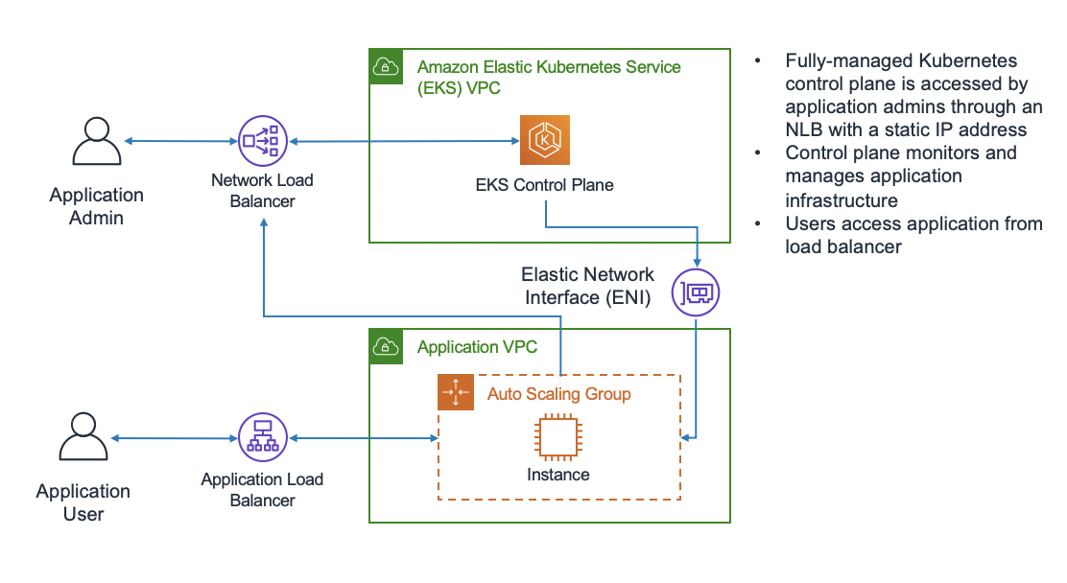
Figure 8.8: Amazon EKS use case (AWS Whitepapers)

Benefits of using Amazon EKS
Key benefits include [29]:
- Operational efficiency: Automates setup, scaling, and management of Kubernetes clusters.
- Security: Integrated with AWS IAM and VPC for secure, isolated networking.
- Flexibility: Supports both standard Kubernetes tools and AWS integrations, providing users with a broad range of options.

Integration with DevOps workflow

EKS integrates seamlessly with DevOps pipelines, enhancing CI/CD practices and accelerating containerized application deployment.

Modern DevOps workflows rely on automation, scalability, and seamless orchestration to accelerate software delivery. Amazon EKS enhances DevOps practices by integrating with popular CI/CD tools, infrastructure-as-code frameworks, and monitoring solutions, enabling containerized applications' efficient, scalable, and cost-effective deployment.

To fully leverage the power of Kubernetes in cloud-native environments, Amazon EKS integrates with essential DevOps tools and practices. The following features illustrate how EKS enhances automation, scalability, monitoring, and cost-efficiency within modern CI/CD pipelines and operational workflows.
- Continuous integration: Works with Jenkins, GitLab CI/CD, and AWS CodePipeline to automate builds and deployments.
- Continuous deployment: EKS automates deployments using Helm and AWS CodeDeploy, ensuring consistent updates.
- Infrastructure as code: Integrates with AWS CloudFormation and Terraform, ensuring consistent environments.
- Monitoring and logging: Works with Amazon Z and AWS X-Ray to provide visibility and initiative-taking troubleshooting.
- Scalability and high availability: Supports auto-scaling and multi-region deployments, ensuring fault tolerance and reduced downtime.
- Cost Optimization: EKS reduces costs with dynamic scaling, AWS Spot Instances, and cost management tools like AWS Cost Explorer.

Wrap up

Amazon EKS streamlines the management of Kubernetes clusters by automating key tasks, improving operational efficiency, and integrating seamlessly with the AWS ecosystem. This service accelerates the deployment lifecycle for containerized applications, helping with high availability, scalability, and security. [29].

AWS App2Container
AWS App2Container is a service that simplifies the process of containerizing legacy applications, enabling organizations to modernize and migrate their applications to cloud-native architectures. This section examines the capabilities of AWS App2Container, its use cases, and the benefits it provides for modern application development.
AWS App2Container facilitates transforming existing applications into containerized environments, minimizing the need for extensive code modifications. It packages an application and its dependencies into containers, allowing users to deploy them in container orchestration environments such as Amazon ECS or Amazon EKS.

Key features of AWS App2Container
The following are the key features of AWS App2Container (AWS, AWS App2Container, 2023):
- Automated containerization: App2Container automatically scans applications and packages them into Docker containers, making the process more efficient and less error prone.
- Support for Java and .NET: The service supports both Java and .NET applications, enabling organizations with legacy systems to migrate to the cloud.
AWS Integration: After containerization, you can easily integrate with Amazon ECS, EKS, or Fargate for orchestration.
Use cases
The following are everyday use cases for AWS App2Container:
- Legacy application modernization: Organizations can use App2Container to modernize legacy applications, enabling them to move from monolithic architectures to containerized solutions.
- Cloud migration: App2Container accelerates the process of migrating applications to the cloud, particularly for organizations moving from on-premises data centers to AWS.
- Microservices conversion: App2Container helps organizations transition to microservices architecture by breaking down legacy monolithic applications into manageable, containerized services.

Benefits of AWS App2Container
The benefits of using AWS App2Container are as follows. [17] :
- Simplified containerization: App2Container automates the containerization process, reducing the complexity of manually configuring and packaging legacy applications.
- Accelerated cloud migration: App2Container helps expedite cloud migration by providing a streamlined approach to containerization, making it easier to migrate workloads to AWS.
Scalability: AWS container services ensure containerized applications perform well as they scale under varying workloads.

Integration with DevOps workflows
AWS App2Container integrates seamlessly into DevOps workflows, allowing developers to incorporate containerization into their continuous integration and deployment (CI/CD) pipelines. This integration streamlines the development-to-production cycle, improving the efficiency of application deployment.

AWS Fargate

AWS Fargate is a serverless compute engine for containers that cuts the need to manage servers. This section discusses how Fargate simplifies container management and provides a scalable solution for running containers in a serverless environment.

Overview
Fargate allows developers to run containers without worrying about the underlying infrastructure. It automatically manages provisioning, scaling, and the compute resources needed to run containers, enabling teams to focus on application logic rather than infrastructure management.

Key features of AWS Fargate
The key features of AWS Fargate include [30]:
- Serverless architecture: Fargate abstracts infrastructure management, enabling developers to focus on writing code rather than managing servers.
- Automatic scaling: Fargate automatically scales the number of containers based on demand, ensuring optimal resource utilization.
- Integration with AWS services: Seamless integration with Amazon ECS, Amazon EKS, and AWS Lambda enables users to run containers in various configurations, enhancing workflows.
Use cases of AWS Fargate
The main use cases are as follows. [30]:
- Microservices architecture: Fargate simplifies microservices management by allowing independent scaling of individual services.
- Batch processing: Fargate can run containerized batch jobs that scale automatically based on workload.
- CI/CD pipelines: Integrating Fargate with CI/CD pipelines enables automation of testing, building, and deployment processes.

Benefits of using AWS Fargate
The benefits of AWS Fargate include:
- Operational simplicity: Fargate eliminates the need to manage infrastructure, reducing the operational complexity associated with running containers.
- Cost efficiency: Fargate offers a pay-per-use pricing model, in which users pay only for the compute resources their containers use.
- Scalability and flexibility: Fargate scales containers based on demand, ensuring applications can manage traffic spikes and fluctuating workloads.
Integration with DevOps workflow
AWS Fargate seamlessly integrates into DevOps workflows, enabling the management and scaling of containerized applications without manual intervention. It works with services like AWS CodePipeline and ECS, helping teams automate their development, testing, and deployment processes. [30].

AWS App2Container and AWS Fargate integration
When combined, AWS App2Container and AWS Fargate offer a comprehensive solution for containerizing and deploying applications:
- Seamless containerization: A2C prepares applications for deployment on Fargate with minimal configuration.
- Serverless deployment: Fargate manages all infrastructure management, providing a fully serverless deployment experience.
- Enhanced efficiency: This integration streamlines container lifecycle management, optimizing resource utilization and minimizing operational overhead.

Benefits of AWS Fargate integration
Integrating the AWS App2Container with AWS Fargate delivers multiple advantages:
- Serverless container orchestration: Fargate automates the entire container orchestration process, freeing developers from managing infrastructure.
- Resource optimization: Fargate scales resources automatically based on application demand, enhancing performance and cost efficiency.
- Simplified operations: The combination of A2C and Fargate simplifies the containerization and deployment process, making operations more efficient.
Use cases
The A2C and Fargate integration is ideal for:
- Microservices architecture: Perfect for deploying individual services independently and efficiently.
- Application modernization: Helps migrate legacy applications to cloud-native environments, enhancing scalability and cost-effectiveness.

AWS Copilot
AWS Copilot is a powerful command-line interface (CLI) that streamlines the deployment, management, and execution of containerized applications on Amazon ECS and AWS Fargate. This section discusses the capabilities, key features, and benefits of using AWS Copilot to streamline the development and deployment of containerized applications.

Overview
AWS Copilot provides a streamlined, opinionated approach to deploying containerized applications. It allows developers to quickly create production-ready environments for their applications without requiring deep knowledge of AWS services. Copilot automates the necessary AWS infrastructure setup, enabling developers to focus on writing code and building features.

Key features of AWS Copilot
The following are the key features of AWS Copilot. [31]:
- Application scaffolding: Copilot automatically generates the necessary AWS infrastructure components, such as load balancers, security groups, and auto-scaling settings, for deploying containerized applications.
- Multi-environment support: AWS Copilot enables the creation and management of applications across multiple environments, including development, staging, and production, ensuring a seamless deployment process for each stage of development.
- Integrated CI/CD: Copilot offers built-in integration with Amazon CodePipeline and GitHub Actions, simplifying automated build and deployment workflows.
- Environment configuration: Copilot enables users to define environment-specific settings for their containerized applications, including resource allocation and environment variables.
Use cases of AWS Copilot
Every day, implementations of AWS Copilot are as follows:
Microservices deployment: Copilot is ideal for deploying microservices, allowing independent scaling and deployment across multiple environments.
- Rapid development and deployment: For teams seeking to develop and deploy containerized applications rapidly, Copilot streamlines the entire process, enabling developers to push code to production quickly without manual configuration.
- Cloud-native migration: Organizations seeking to migrate their containerized applications from on-premises or other cloud environments to AWS can seamlessly transition to Copilot.

Benefits of AWS Copilot
The benefits of using AWS Copilot are as follows. [31]:
- Simplified application deployment: Copilot streamlines the deployment of containerized applications by automating much of the setup, making it easier for developers to deploy their applications quickly and reliably.
Default practices: The service follows AWS guidelines for security, scalability, and cost efficiency, ensuring that applications are deployed securely and perform optimally.
- Faster time to market: With automated infrastructure setup and integration with CI/CD tools, Copilot accelerates the development cycle, enabling teams to release applications more quickly.

Integration with DevOps workflows
AWS Copilot integrates smoothly into DevOps workflows by providing a simplified yet powerful toolset for managing containerized applications in AWS. It enables automated deployment through continuous integration and delivery pipelines, making it an ideal choice for organizations looking to streamline their DevOps processes and keep a consistent, repeatable deployment flow.

AWS App2Container and AWS Copilot integration
Combining AWS App2Container with AWS Copilot delivers a robust solution for containerizing and deploying legacy applications into scalable, serverless environments.
As organizations modernize their legacy applications, they require efficient tools that automate containerization and deployment while minimizing complexity. The integration of AWS App2Container and AWS Copilot provides a comprehensive solution for transitioning traditional applications into cloud-native, scalable environments without disrupting existing workflows.
The combination of AWS App2Container and AWS Copilot empowers organizations to modernize legacy applications with minimal disruption. The following key features highlight how these tools work together to automate containerization, simplify deployment, and integrate seamlessly with modern DevOps workflows.
- Seamless migration & deployment: App2Container prepares legacy applications by generating Docker images, and AWS Copilot simplifies the deployment process, ensuring a streamlined CI/CD pipeline and environment setup.
- Simplified container management: App2Container automates containerization, and Copilot handles deployment and scaling with minimal configuration, enabling developers to focus on application logic.
- End-to-end DevOps integration: Integrates with AWS CodePipeline, enabling automated continuous integration and deployment and supporting agile DevOps workflows.

Benefits of AWS App2Container and Copilot integration
Organizations leveraging AWS App2Container and Copilot gain a streamlined approach to modernization. By automating containerization, deployment, and scaling, these tools enhance operational efficiency and accelerate cloud adoption while ensuring cost optimization through AWS’s flexible pricing model.
- Accelerated modernization: Quickly migrate legacy applications to containerized environments, reducing the manual work in modernizing legacy systems.
- Operational efficiency: App2Container and AWS Copilot simplify container management and deployment, reducing operational complexity.
- Cost efficiency: AWS's pay-as-you-go pricing model allows organizations to pay only for the resources they use, improving cost management.
Use cases
AWS App2Container and Copilot cater to businesses aiming to transition effortlessly to containerized environments. Whether modernizing legacy applications or integrating with DevOps pipelines, these tools simplify deployment, management, and scaling, making cloud adoption more accessible and efficient.
- Legacy application modernization: Easily containerize and migrate traditional applications to modern cloud-native architectures.
- CI/CD integration: This will simplify the integration of containerized applications into continuous integration and delivery workflows, enhancing DevOps practices.

Red Hat OpenShift service on AWS
The Red Hat OpenShift Service on AWS (ROSA) is a fully managed Kubernetes service that combines the power of Red Hat OpenShift with the scalability of AWS infrastructure. This section delves into ROSA's capabilities, benefits, and use cases for organizations seeking a streamlined, enterprise-grade platform for deploying and managing containerized applications on AWS. [32]

Overview of Red Hat OpenShift service on AWS
ROSA integrates Red Hat OpenShift's container orchestration capabilities with AWS’s cloud infrastructure. By providing a fully managed Kubernetes environment, ROSA simplifies the' deployment, scaling, and management of containerized applications while using the operational benefits of OpenShift’s enterprise features, such as integrated CI/CD pipelines and enhanced security. [32]

Key features of the Red Hat OpenShift service on AWS
As organizations embrace containerized application development, they require a fully managed, enterprise-grade Kubernetes solution that simplifies deployment and operations. ROSA (Red Hat OpenShift Service on AWS) bridges the gap between Kubernetes flexibility and enterprise-ready features, offering a seamless cloud-native experience [32].
- Enterprise-grade Kubernetes: ROSA combines Kubernetes's flexibility and power with Red Hat OpenShift’s added capabilities, such as integrated logging, monitoring, and CI/CD tools.
- Fully managed service: ROSA manages the installation, configuration, and management of OpenShift clusters, allowing teams to focus on developing applications without worrying about the underlying infrastructure.
- Seamless integration with AWS: ROSA integrates with AWS services like Amazon RDS, Amazon S3, and AWS Identity and Access Management (IAM) to provide a robust platform for cloud-native application deployment.
Enhanced security and compliance: Red Hat OpenShift integrates ROSA with RBAC, automated patching, and security updates to ensure enterprise security standards for your applications.

Benefits of Red Hat OpenShift service on AWS
Businesses seeking faster deployment cycles and operational efficiency benefit from ROSA’s fully managed infrastructure. By combining automated scaling, built-in security, and deep AWS integration, ROSA enables teams to focus on building and deploying applications rather than managing clusters. [32]
- Faster time to market: ROSA accelerates application development and deployment with integrated CI/CD workflows, automated scaling, and simplified management.
- Operational efficiency: By offloading the management of Kubernetes clusters and infrastructure to AWS, ROSA reduces the operational burden on DevOps teams, allowing them to focus on building and deploying applications.
- Scalability and flexibility: ROSA leverages AWS's elastic compute resources to scale containerized applications dynamically, ensuring high availability and best performance under varying workloads.
- Security and compliance: ROSA offers built-in enterprise security features, including network isolation, IAM integration, and automated updates, ensuring that applications meet stringent compliance and security requirements.
Use cases for Red Hat OpenShift Service on AWS
ROSA supports modern application development, including microservices and hybrid cloud strategies. With its integrated CI/CD pipelines, scalability, and cross-cloud compatibility, ROSA provides an optimized environment for enterprises to accelerate their digital transformation initiatives. [32].
Red Hat OpenShift Service on AWS (ROSA) provides a flexible and scalable platform to address various modern application development needs. The following case studies highlight how organizations can leverage ROSA to support containerized workloads, enhance deployment strategies, and drive operational efficiency across hybrid and cloud-native environments.
- Microservices architecture: ROSA supports the deployment and management of microservices, enabling teams to break down applications into more minor, independently deployable services.
- Hybrid cloud deployments: ROSA is ideal for hybrid cloud environments, allowing organizations to run containerized applications both on-premises and on AWS, seamlessly integrating with on-premises infrastructure
- CI/CD pipelines: With built-in CI/CD capabilities, ROSA enables automated testing, integration, and deployment of containerized applications in fast-moving environments.

Integration with AWS services
ROSA integrates tightly with various AWS services, enhancing the management and deployment of containerized applications [32]:
- Amazon RDS and Amazon EFS: ROSA can easily integrate with Amazon RDS for relational database services and Amazon EFS for scalable storage, making it suitable for applications with diverse data storage needs.
- Amazon CloudWatch: Integration with CloudWatch enables monitoring and logging of containerized applications, providing insights into performance, errors, and system health.
- AWS IAM: ROSA uses AWS IAM to manage resource access, providing fine-grained control over who can access OpenShift resources within the AWS cloud environment.

Managed OpenShift in the Cloud
Managed OpenShift in the Cloud offers a fully managed Kubernetes platform designed to accelerate the development and deployment of containerized applications. This service combines the power of Red Hat OpenShift with the scalability of public cloud providers like AWS, allowing organizations to focus on application development while leaving the management of the underlying infrastructure to the provider. [24].

Overview of managed OpenShift in the Cloud
Managed OpenShift in the cloud simplifies deploying, managing, and scaling containerized applications. With OpenShift's powerful Kubernetes orchestration and enterprise-grade features, teams can use an integrated platform that simplifies container management, scaling, and security. Whether it is an on-demand service or private cloud deployment, managed OpenShift offers a robust platform that integrates seamlessly with a wide range of cloud-native tools and services. [24].

Key features of managed OpenShift in the Cloud
Organizations leveraging Managed OpenShift in the cloud gain access to a fully integrated Kubernetes solution designed for enterprise-scale application deployment. With enhanced security, automation, and cloud-native integrations, OpenShift simplifies the complexities of managing containerized workloads while ensuring flexibility and efficiency. [24].
Managed OpenShift in the cloud offers powerful features that simplify Kubernetes operations while addressing enterprise demands for security, scalability, and operational efficiency. The following key features demonstrate how OpenShift enables organizations to confidently deploy and manage containerized applications across diverse cloud environments.
- Enterprise-Grade Kubernetes: Managed OpenShift brings Kubernetes orchestration with added security, scalability, and enterprise capabilities, making it ideal for organizations with complex application needs.
- Simplified application deployment: OpenShift's native tools for automated deployment, Continuous Integration/Continuous Delivery (CI/CD) pipelines, and monitoring streamline the process of getting applications up and running in the cloud.
- Integrated security features: The platform offers built-in security features, including Role-Based Access Control (RBAC), automated patching, and vulnerability scanning, to protect applications in production.
- Cloud-native integrations: Managed OpenShift integrates seamlessly with cloud services like storage, networking, and identity management tools, enabling flexible, cloud-native application architectures.

Benefits of managed OpenShift in the Cloud
By offloading infrastructure management, organizations can focus on innovation rather than operational challenges. Managed OpenShift delivers scalability, security, and automation, enabling businesses to streamline development workflows, maintain compliance, and optimize performance across dynamic cloud environments. [24].
- Reduced operational overhead: By outsourcing the management of Kubernetes clusters and OpenShift components, development teams can focus on building applications rather than managing infrastructure.
- Scalability and flexibility: Managed OpenShift in the cloud dynamically scales resources based on application load, ensuring high availability and performance.
- Simplified CI/CD: With built-in CI/CD capabilities, OpenShift accelerates the development cycle, automating testing, integration, and deployment pipelines.
- Enhanced security and compliance: Managed OpenShift in the cloud integrates with IAM (Identity and Access Management) and provides comprehensive logging, monitoring, and auditing features that help meet stringent security and compliance requirements.

Use cases for Managed OpenShift in the Cloud.
Businesses adopting modern cloud strategies require platforms that support scalable architecture, hybrid deployments, and DevOps automation. Managed OpenShift caters to diverse workloads, from microservices-driven applications to hybrid cloud integrations and fully automated CI/CD pipelines, making it a preferred solution for enterprises embracing cloud-native development. [24].
By adopting managed OpenShift in the cloud, organizations can unlock a wide range of benefits that go beyond simplified container management. The following benefits illustrate how OpenShift accelerates development, optimizes resources, and strengthens security while reducing operational complexity.
- Microservices deployment: Managed OpenShift is ideal for organizations transitioning to a microservices architecture. It supports the deployment and management of microservices at scale.
- Hybrid Cloud solutions: Managed OpenShift offers seamless integration with public and private cloud environments, enabling hybrid cloud strategies and allowing organizations to run applications across diverse cloud platforms.
- DevOps and CI/CD pipelines: Managed OpenShift simplifies the adoption of DevOps practices by integrating CI/CD pipelines directly into the platform, ensuring smooth and consistent deployment processes.

Integration with AWS services
Managed OpenShift in the cloud integrates with various AWS services, enhancing its capabilities and extending its use for different application needs. [24].
Managed OpenShift in the cloud supports diverse use cases across industries and workloads. The examples below highlight how organizations leverage OpenShift to modernize their application architectures, implement hybrid cloud strategies, and streamline DevOps practices.
Amazon EC2 and Amazon S3: Integrated with Managed OpenShift, these services offer scalable computing and secure cloud storage.
- AWS IAM: Integrated with AWS IAM, Managed OpenShift ensures secure access control for cloud resources and provides robust identity and permissions management.
- Amazon CloudWatch: Managed OpenShift integrates with Amazon CloudWatch for monitoring, enabling organizations to track application performance metrics, logs, and health status in real time.

Robotics: AWS RoboMaker
AWS RoboMaker simplifies the development, testing, and deployment of robotics applications in the cloud. It provides comprehensive tools for building intelligent robots, including simulation environments, fleet management, and Robot Operating System (ROS) integration. RoboMaker supports a streamlined workflow, from development and simulation to deployment. [33].

Key features and capabilities
AWS RoboMaker equips developers with a comprehensive suite of tools for building, testing, and deploying robotics applications on a scale. By offering realistic simulation environments, fleet management solutions, and deep integration with ROS, RoboMaker accelerates the development lifecycle of intelligent robots.
- Simulation environments: AWS RoboMaker provides realistic testing scenarios before deploying applications to physical robots [33].
- Fleet management: It provides tools for efficiently managing and scaling robot fleets.
- ROS integration: Seamlessly integrates with ROS, allowing compatibility with widely used robotic frameworks [33].
Figure 7.10 illustrates AWS RoboMaker's simulation service to visualize how it helps cloud-based robotic development. It highlights how realistic simulations refine and evaluate robotic applications before deploying them to physical robots.

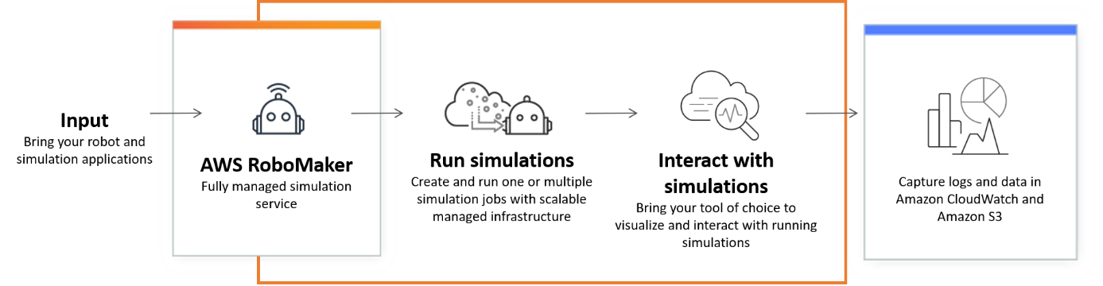
Figure 7.10AWS RoboMaker cloud-based simulation service (AWS Documentation)

Workflow
RoboMaker's workflow covers:
- Development: Use the integrated IDE to build and debug applications.
- Simulation: Test applications in virtual environments to refine robot behavior.
- Deployment: Deploy tested applications to physical robots using RoboMaker [33].

Integration with AWS services
Seamless integration with AWS services enhances robotics applications' scalability, storage, and automation. AWS RoboMaker leverages cloud-native capabilities to manage robotics infrastructure efficiently, ensuring secure data storage and scalable deployments [33].
- Amazon S3: Store simulation data and model files.
- AWS CloudFormation: Provision infrastructure for robotics applications.
Use cases
AWS RoboMaker is used in industrial automation, research, and education, providing a cloud-based platform for robotics development. Organizations leverage RoboMaker to enhance operational efficiency, streamline development, and enable innovative research in AI-driven robotics.
- Industrial automation: Automating tasks like material handling and inspection.
- Research and education: Supporting robotic research and educational purposes [33].

Quantum technologies in AWS
Quantum technologies represent a significant leap forward in computing, harnessing the principles of quantum mechanics to enable robust computation. AWS helps the adoption of quantum computing through services like Amazon Braket, providing access to diverse quantum processors and tools to experiment with quantum algorithms [34].

Key concepts
Understanding the fundamental principles of quantum computing is crucial for leveraging its computational advantages. AWS provides resources to explore key concepts in quantum mechanics, including qubits, quantum gates, and entanglement, which form the foundation of quantum algorithms and computation [34].
The foundational concepts of quantum computing provide the basis for understanding how this emerging technology differs from classical computing. AWS enables users to explore these critical principles underpinning quantum algorithms and their unique capabilities.
- Qubits and Quantum Gates: Qubits exist in multiple states simultaneously, enabling complex computations.
- Entanglement: Qubits influence each other across distances, a fundamental property of quantum systems.

Amazon Braket
Amazon Braket serves as AWS's gateway to quantum computing, offering a unified environment for designing, evaluating, and executing quantum algorithms. It provides researchers and developers access to multiple quantum processors and hybrid computing resources, enabling real-world experimentation with quantum mechanics.
By bridging classical and quantum computing, Amazon Braket enables users to explore next-generation computational models and push the boundaries of problem-solving in optimization, cryptography, and materials science.
Amazon Braket offers a comprehensive set of features that allow users to experiment with quantum computing in a practical and scalable environment. The following capabilities illustrate how Amazon Braket empowers organizations to explore quantum workflows using AWS’s managed services.
- Quantum processors: Access to multiple quantum processors for varied algorithm testing.
- Quantum tasks: Execute quantum tasks by selecting processors and algorithms.
- Hybrid quantum-classical computing: Combines quantum and classical computing for complex problem-solving [34].

Integration with AWS services
AWS seamlessly integrates quantum computing with its existing cloud infrastructure, enabling businesses to store, process, and analyze data generated by quantum computing. Organizations can enhance efficiency and extend quantum computing capabilities to broader applications by combining quantum resources with AWS services. [34].
The integration of Amazon Braket with other AWS services extends the value of quantum computing by enabling efficient data storage, processing, and event-driven automation. The following services exemplify how quantum tasks can interact with AWS’s broader cloud ecosystem:
- Amazon S3: Store quantum data and results.
- AWS Lambda: Execute serverless functions triggered by quantum tasks.
Use cases
Quantum computing has the potential to revolutionize industries by tackling problems beyond the reach of classical computing. AWS Braket enables researchers, scientists, and businesses to experiment with quantum algorithms, optimize computations, and explore novel applications in fields such as cryptography, materials science, and artificial intelligence [34].
- Quantum algorithm development: For refining and testing algorithms.
- Exploring quantum capabilities: Testing quantum computing applications without dedicated infrastructure.

Challenges
Despite its transformative potential, quantum computing faces diverse technical and practical challenges. Issues such as error rates, resource optimization, and quantum decoherence require ongoing hardware and algorithm development advancements. AWS provides tools and research support to address these challenges, helping users maximize the benefits of quantum computing [34].
- Error correction: Quantum computing’s susceptibility to errors requires effective strategies.
- Resource allocation: Optimal quantum processor and task configuration are key to success.

Developer tools and DevOps in AWS
AWS Developer Tools and DevOps services empower development teams by automating software delivery, optimizing infrastructure management, and enhancing operational efficiency. These tools facilitate continuous integration and continuous delivery (CI/CD), infrastructure provisioning, and deployment automation, enabling developers to concentrate on their work rather than manual configurations. [35] [36]. The following key areas highlight how AWS accelerates modern DevOps workflows:
- CI/CD: Integrating AWS CodeCommit and AWS CodePipeline streamlines code management and automation [37]; [38].
- Cloud Development Kit: AWS CDK promotes Infrastructure as Code, making it easier to define cloud infrastructure [39].
- DevOps Automation: Tools like AWS CodeDeploy and AWS Fargate simplify deployment and management [40]; [30].
Integrating AWS tools into DevOps and cloud development workflows boosts efficiency, security, and scalability. These tools provide seamless solutions for application management, fostering rapid deployment and innovation.

Conclusion
This chapter revolved around AWS Developer Tools, DevOps solutions, application integration services, container management, robotics, and quantum technologies. These services empower developers to innovate, collaborate, and deploy applications with speed, scalability, and reliability. AWS supports the entire software development lifecycle, making it a cloud provider and a comprehensive ecosystem for code creation, collaboration, deployment, and monitoring.
The evolution of cloud computing, with AWS at the forefront, highlights its role in shaping the future of technology. From traditional development to quantum computing, AWS provides the tools necessary to navigate this transformative landscape.
Next, we will explore AWS's powerful analytics and machine learning tools, including Amazon Redshift, Athena, AWS Glue, and SageMaker. Chapter 9, End-user, Front-User, and Mobile, will equip you with the skills to harness data and machine learning, driving innovation and insights in your applications.

